**M10 - Anthropometrics and Ergonomics**

**General Information for Module M10**

**Anthropometrics –** These are the issues associated with the physical size, weight and shape of the human form.

**Ergonomics -** These are the physical factors that make a product easier to use.

**What are Anthropometrics & Ergonomics?**

The term “**Human Factors” and “Ergonomics**” are interchangeable terms and mean the same thing. The title “human factors” is commonly used in the United States whereas, “ergonomics” is widely used in many other global regions such as Europe. Ergonomics is all about considering and improving the function of a product by considering the physical characteristics of the people who will use it. For example, this could be making a product more comfortable or easier to use by altering its shape, size, weight, surface texture or any other characteristic. Design innovation or modification based on ergonomic principles can be seen in most everyday products. From the shape of golf clubs, the handles of tools, furniture, shoes transport vehicles and cutlery. Sometimes the ease of use is the driving factor for design change, sometimes it is improved performance or it might just be personal preference or fashion. Occasionally it is the development of new materials or manufacturing techniques.

Whatever the reason the outcome is always a product intended to improve our quality of life.

**Anthropometrics -** refers specifically to the collection of data about the size, shape, weight and movement of the human body (statistics that relate to the human form). Anthropometric data is collected and used to inform the design process. Anthropometrics is inter-linked closely to ergonomics because it deals with body measurements, particularly those of size, strength, and physical characteristics which, in turn, make a product easier to use.

The anthropometric characteristics of the intended user group are affected by age, gender, geographical region and disability. Over many years Scientists and Designers have been collecting the Anthropometric data of people from all over the world. This information has been shared and assembled into huge databases which are used by the Designer to create products that will fit the physical characteristics of user groups from every region of the world.

When creating a new product Designers have to consider how the user will interact with the product. This means analysing how the product will be used and creating a design which makes the product easier to use, will not cause injury to the user and will not cause un-necessary wear and tear on the product.

By using anthropometric information Designers can create products which are best suited to the size for their target user group. The process/technique of making products easier to use by designing them to fit the physical characteristics of the user is called **Ergonomics**. There are many examples of ergonomically designed products. *(Using an internet search; look at traditional keyboards and ergonomic keyboards, then find out why the manufacturers claim that they are better.)*

The collection of anthropometric data has enabled scientist to identify the various ranges of human shapes and sizes.

**In statistics there are two types of data collection PRIMARY DATA and SECONDARY DATA**

* **PRIMARY DATA** – is information collected by a manufacturer or designer specifically for use by them in the development of a product. The collection of primary data is a laborious and time consuming process which is very expensive.
* **SECONDARY DATA –** is information which has been already collected by some agency for a different specific purpose and then used in an alternative situation from that which they were originally intended.

**What is a normal distribution curve?**

This is the expected shape of a graph that is produced when collecting data about most common phenomenon.

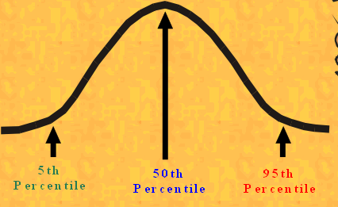

The use and application of the terms; **5th Percentile, 50th Percentile and 95th Percentil**e are key concepts in anthropometrics. The larger the target user group the more generic their characteristics become. Therefore, the larger the user groups the wider the range of data that must be collected. Regional/cultural factors must also be taken into account. There are differences in size and weight between nationalities and continents. (E.g. the seat spacing for passengers on a short-haul aircraft versus the seat spacing on a long-haul aircraft.) The larger the user group the greater the range of anthropometric data such as height/weight that must be used.

[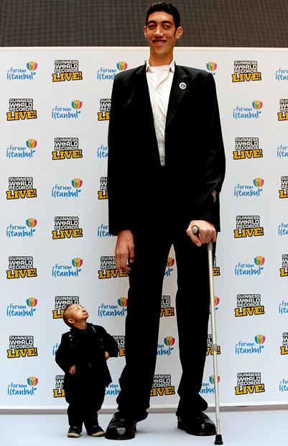](http://www.google.co.uk/url?sa=i&rct=j&q=&esrc=s&frm=1&source=images&cd=&cad=rja&uact=8&ved=0CAcQjRw&url=http://www.telegraph.co.uk/news/picturegalleries/howaboutthat/6988398/The-worlds-tallest-man-Sultan-Kosen-and-the-shortest-man-in-the-world-He-Pingping-meet.html&ei=83JoVbvgF8G4UZjXgYgI&bvm=bv.94455598,d.d24&psig=AFQjCNGohuV8qUepnJ2LLO-nqIpXDB0Pyg&ust=1432994929676818)

Mass produced products are generally intended for use by the majority of the target user group. But not everyone in the target group will have standard features.

Remember, it is very unlikely that anyone is average. Average is a mathematical concept and half of the target user group will be below the average and half will be above.

When designing for the mass market Designers will create products that fit the characteristics of the user group between the 5th and 95th percentiles. These people are called **Population Stereotypes.** This is the term used to describe those people with the most common features from the target population. The 50th percentile is that group of people with the most common physical features and that is the “model person for the target user group” that mass made products are made to fit. **Extremes of User Population - (5th & 95th Percentiles**) are those members of a user group whose physical attributes fall into the 5th or 95th Percentile groups are regarded as extreme physical features. As such, their physical characteristics are often not included when considering the design of a product. The reasoning for this is purely pragmatic; it is usually impossible for a designer or manufacturer to produce a single product that is easy to use for every member of the target user group. Frequently, the physical features of every member of the user group are so varied the designer/manufacturer will attempt to the produce a product that is useable by the greatest number of people in the target user group.

**Static & Dynamic Anthropometric Data**

* **Static Anthropometric Data** is factual/objective measurements of the human form taken when the person is still. E.g. their weight, height, leg length, shoe size etc.
* **Dynamic Anthropometric Data** is collected when people are moving. E.g. When undertaking an activity such as moving to sit in a chair, repeatedly lifting an object from one place to another, crash dummies in car safety testing. Running styles and foot rotation for shoe design.

Static Data is very reliable and consistent whereas Dynamic Data is harder to collect. However, dynamic data is often more useful because it is more informative about how people will respond in a particular situation with a specific product.

**Instruments used for the collection of Anthropometric Data**

Various standardised instruments have been developed for the collection of anthropometric data. These instruments have been standardised in order to ensure the consistency of measurements and operation which will ensure the consistency of the quality of data collected.

Such instruments are; Sliding Callipers

Stadiometer

Torso Callipers

Cloth Tape measures

Harpenden anthropometer

**Physiological Factors**

Designers study physical characteristics to optimise the user’s safety, health, comfort and performance. Poor design can cause injuries or make a process more dangerous. Therefore, Designers must be fully aware of the physical limitations of the target user group and take account of issues such as muscle strength, age, user interface and torque. This has resulted in the scientific study of the physical capability of humans known as Biomechanics.

**Biomechanics and Applying Biomechanics to the design of a product**

Biomechanics is the research and analysis of the way living organisms move. For humans this is all aspects of the physiology of movement. How the human skeleton and muscles interact to enable movement; and how physical activities impact upon human health and comfort.

An understanding of and reference to biometric data is essential when designing a product. Repetitive Injury Syndrome can be significantly reduced by the redesigning of a product. Failure to take account of biometric data when designing a product can lead to the product of a product which is inefficient, cause personal injury or excessive fatigue.

Example A: Posture and the relationship between table working heights and chair seat levels.

Example B: The layout of controls on equipment or the shape of a keyboard on a computer.

Example C: The working activity and the light levels in a work area.

**Designing for Discomfort**

Occasionally a Designer is required to design a product intended to cause discomfort. The reasons are usually obvious but the designing is always very subtle.

* It might be that an interior designer is required to produce a design for a fast food outlet. By their nature fast food means fast turnover of customers so the owner does not want to make the customers too comfortable. Comfortable furniture will encourage customers to linger and relax whereas the owner wants them to pay, eat and go in a very short time. High customer turnover means higher sales for the owner.
* Teenagers frequently gather in groups in Shopping Malls or outside of supermarkets when they are closed. This often ends up with low level vandalism or anti-social behaviour which costs the shop owners money in terms of repairs or lost revenue due to customers put off from walking through a gauntlet of intimidating teenagers. The owner could call for security or the police to move the teenagers on or they could get a designer to solve the problem. As a person gets older their hearing range decreases so that they cannot hear high frequency noise. By placing a high frequency speaker out of sight in the problem area young people find hanging around in the area uncomfortable or even painful so they move away.
* Manufactures of fire alarms want to ensure that the public evacuate a building in the event of a fire. Therefore they make the alarm so loud that it is painful to stay in the building while the alarm is sounding and the noise drives them out of the building. Also there is a much reduced chance that someone might not hear it.

There will always be occasions when designed discomfort conflicts with user needs. For example;

* Airport seating is designed for quick passenger turnover but occasionally there are long flight delays.
* Fast food restaurants want to encourage large family groups to use the facilities but the older family members will be reluctant because the seating is uncomfortable.

In these circumstances there will always be a conflict of interests. The Designer will always have to seek a compromise between comfort, aesthetics and functionalism. For example, public seating in railway stations needs to be robust, easy to maintain, look good, resist vandalism and be relatively cheap. This can be achieved by intuitive designs and appropriate materials selection.

**\*\*\*\***

**Now answer the questions on the next page**

**Anthropometrics & Ergonomics - Unit Assessment**

Referring to the information contained in this booklet answer the following 8 questions

Q1. What do the 5th & 95th percentiles refer to?

Q2. In your own words and in one sentence explain the difference between ergonomics and anthropometrics.

Q3. What is a target user group?

Q4. Would the designer of a chair use ergonomic or anthropometric data? State which one and why.

Q5. In your own words explain what is meant by the term biomechanics.

Q6. What anthropometric data would the designer of a dining room chair need?

Q7. What is different about an ergonomically design computer keyboard compared to a standard keyboard?

Q8. What is a Harpenden anthropometer used for?

Q9. Would the designer of a mobile phone consider anthropometric or ergonomic factors when designing a new product? State which one and why.

Q10. State three factors that a designer would need to address when designing the seats in a fast-food restaurant.